Supplementary Materials

*Unfinished – for your reference only

Table S1. Physical characteristics of study sites. Regions include West Vancouver (WV) and the Southern Gulf Islands (SGI). Vertical height refers to height above Canadian chart datum. Slope refers to degrees above the horizontal. Aspect refers to degrees east of magnetic north.

Site | Region | Salinity Category | Latitude | Longitude | Vertical Height (m) | Slope (°) | Aspect (°) | Primary Rock Type
LS1 | WV | Low | 49°28’14”N | 123°14’39”W | 3.3 | 10-22 | 210-280 | Granite
LS2 | WV | Low | 49°22’43”N | 123°16’49”W | 3.8 | 19-37 | 250-320 | Granite
LS3 | WV | Low | 49°20’18”N | 123°13’14”W | 3.3 | 9-16 | 80-210 | Granite
HS1 | SGI | High | 48°59’25”N | 123°34’52”W | 2.3 | 10-33 | 40-60 | Sandstone
HS2 | SGI | High | 48°45’23”N | 123°23’49”W | 2.4 | 1-26 | 150-230 | Granite
HS3 | SGI | High | 48°46’24”N | 123°21’59”W | 2.0 | 4-16 | 85-120 | Granite

Figure S1. Abundance of a) Littorina spp. and percent cover of b) B. glandula, c) M. trossulus and d) F. gardneri from transect surveys in high salinity sites (Gulf Islands) and low salinity sites (West Vancouver). Error bars indicate standard errors.

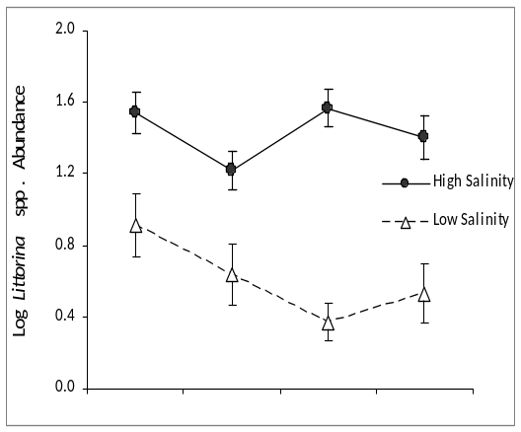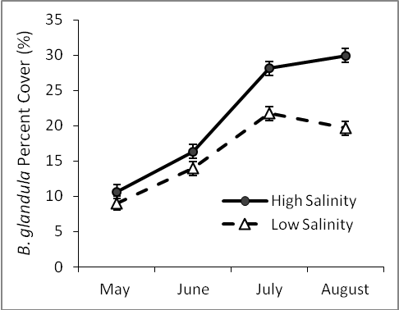
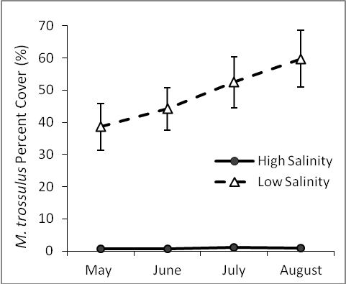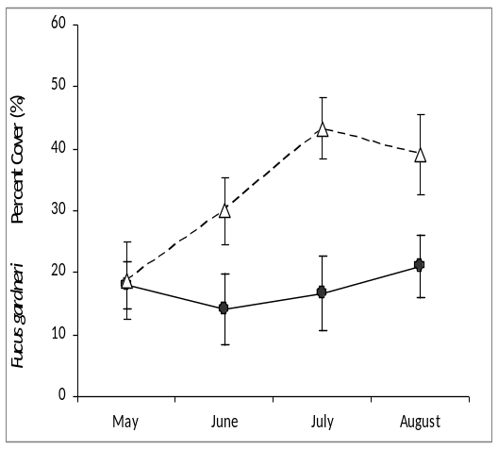
Table S2. Statistical analyses of the effect of Salinity (high vs low) and Month (May through August) on the abundance of organisms (Repeated Measures MANOVA). Significant effects (p<0.05) are highlighted in bold.

 | Salinity |  |  |  | Month |  |  |  | Salinity*Month
 | df | F | p |  | df | F | p |  | df | F | p
Lottia spp. | 1,42 | 180.55 | <0.001 |  | 3,40 | 5.19 | 0.004 |  | 3,40 | 10.81 | <0.001
Littorina spp. | 1,42 | 81.93 | <0.001 |  | 3,40 | 2.56 | 0.069 |  | 3,40 | 6.09 | <0.001
B. glandula | 1,42 | 5.50 | 0.024 |  | 3,40 | 13.28 | <0.001 |  | 3,40 | 0.72 | 0.545
C. dalli | 1,42 | 85.36 | <0.001 |  | 3,40 | 4.49 | 0.008 |  | 3,40 | 5.49 | 0.003
M. trossulus | 1,42 | 235.29 | <0.001 |  | 3,40 | 5.71 | 0.013 |  | 3,40 | 5.02 | 0.024
Green Algae | 1,42 | 2.49 | 0.122 |  | 3,40 | 7.74 | <0.001 |  | 3,40 | 4.81 | 0.006
Red Algae | 1,42 | 12.12 | 0.001 |  | 3,40 | 2.59 | 0.066 |  | 3,40 | 0.75 | 0.530
F. gardneri | 1,42 | 9.84 | 0.003 |  | 3,40 | 5.61 | 0.003 |  | 3,40 | 4.35 | 0.010

Figure S2. Mean proportion of limpets L. pelta with and without tidal treatment alive at each day for six salinity treatments (n=4). Error bars indicate standard error.

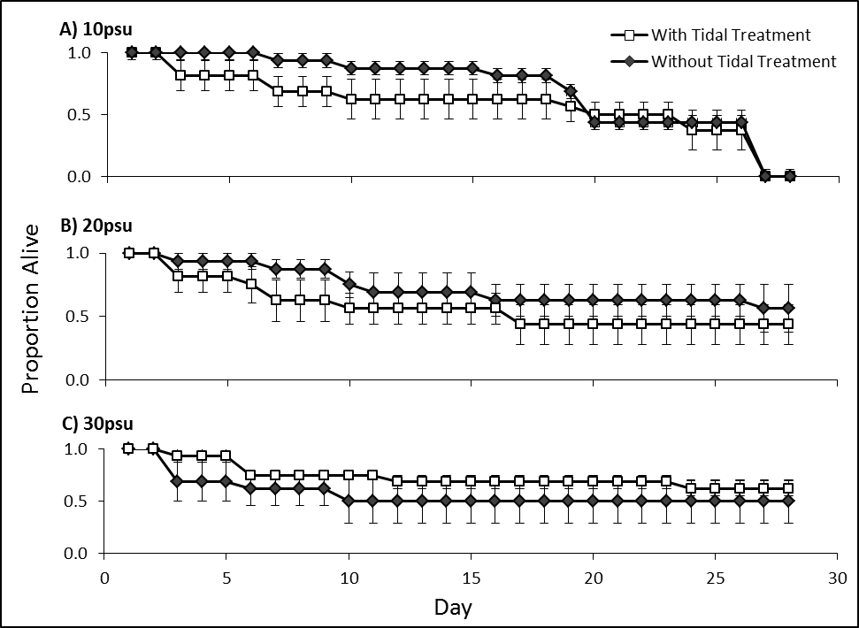
Figure S3. Mean proportion of L. digitalis with and without tidal treatment alive at each day for six salinity treatments (n=4). Error bars indicate standard error.

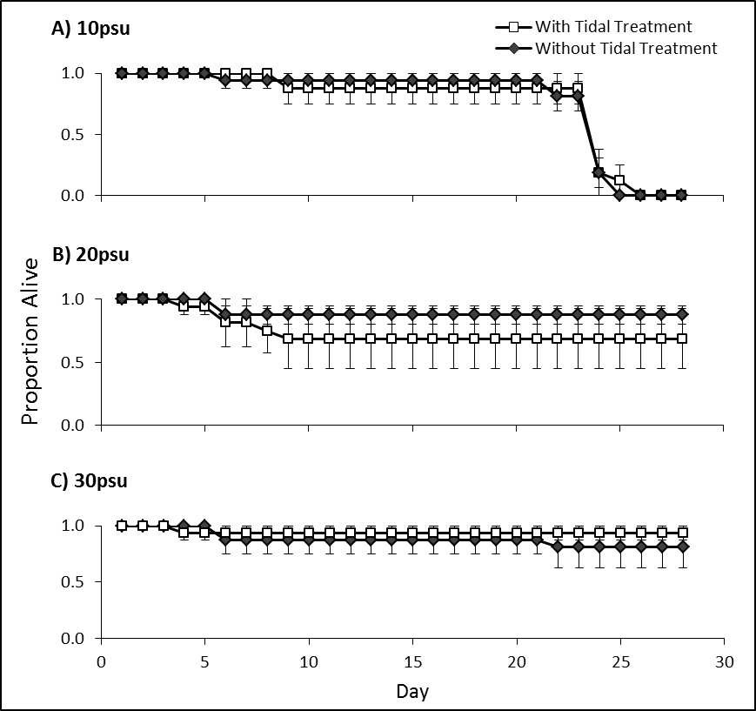
Figure S4. Mean abundance of a) Lottia spp., b) Littorina spp. and c) B. glandula, and percent cover of d) F. gardneri in each treatment at high and low salinity for the month of July. Error bars indicate standard error. Letters indicate results of Tukey’s HSD. All abundance data have been log transformed.

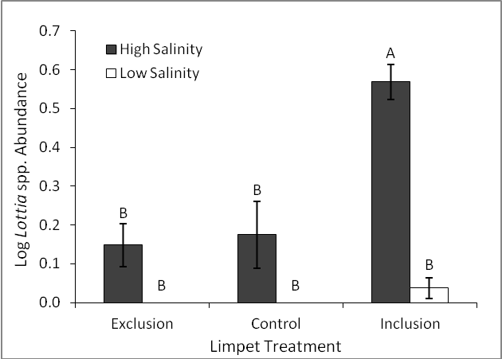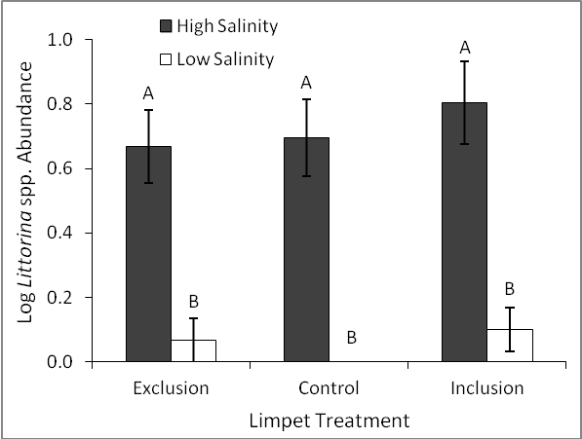
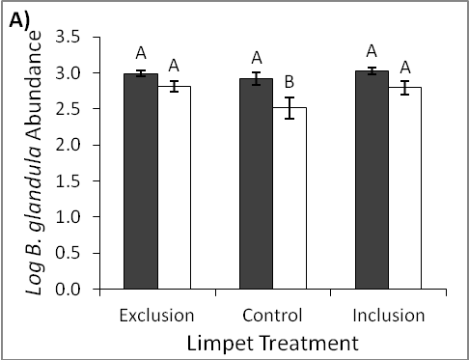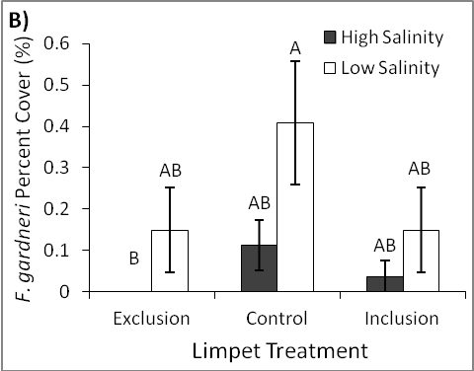
Table S3. Statistical analyses of the effects of salinity (high vs. low) and treatment (exclusion, control, inclusion) on the abundance of organisms (Fixed Effects ANOVA) for July. Significant effects (P<0.05) are highlighted in bold.

 | Salinity |  |  |  | Treatment |  |  |  | Salinity*Treatment
 | df | F | p |  | df | F | p |  | df | F | p
Lottia spp. | 1 | 59.67 | <0.001 |  | 2 | 16.19 | <0.001 |  | 2 | 11.25 | <0.001
Littorina spp. | 1 | 66.55 | <0.001 |  | 2 | 1.17 | 0.314 |  | 2 | 0.31 | 0.736
B. glandula | 1 | 25.87 | <0.001 |  | 2 | 5.41 | 0.006 |  | 2 | 1.61 | 0.204
C. dalli | 1 | 24.94 | <0.001 |  | 2 | 12.10 | <0.001 |  | 2 | 15.78 | <0.001
M. trossulus | 1 | 2.35 | 0.128 |  | 2 | 0.93 | 0.397 |  | 2 | 0.85 | 0.431
Green Algae | 1 | 49.62 | <0.001 |  | 2 | 2.96 | 0.056 |  | 2 | 7.04 | 0.001
Red Algae | 1 | 12.17 | <0.001 |  | 2 | 1.09 | 0.340 |  | 2 | 0.85 | 0.431
F. gardneri | 1 | 6.32 | 0.013 |  | 2 | 2.55 | 0.082 |  | 2 | 0.59 | 0.556

